**Create a Student table and ADD 20 records in them**

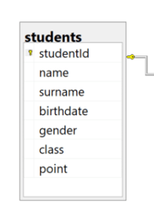

**Example 1: List all the records in the student chart**

**Example 2: List the name surname and class of the student in the student table**

**Example 3: List the gender Female (F) records in the student table**

**Example 4 : List the names of each class in the way of being seen once in the student table**

**Example 5: List the students with Female gender and the class 10Math in the student table**

**Example 6: List the names, surnames and classes of the students in the class 10Math or 10Sci in the student table**

**Example 7: List the students name surname and school number in the student table**

**Example 8: List the students name and surname by combining them as name surname in the student table**

**Example 9: List the students with the names starting with “A” letter in the student table**

**Example 10: List the book names and pages count with number of pages between 50 and 200 in the book table**

**Example 11: List the students with names Emma Sophia and Robert in the student table**

**Example 12: List the students with names starting with A D and K in the student table**

**Example 13: List the names surnames classes and genders of males in 9Math or females in 9His in the student table**

**Example 14: List the males whose classes are 10Math or 10Bio**

**Example 15: List the students with birth year 1989 in the student table**